**FPT Aptech**

--- o0o ---

**PROJECT REPORT**

**<TechBlog>**

Batch: T1804E

Semester: 2

Group: Group3

Nguyễn Tiến Thịnh

Phạm Thành Đạt

Lê Quang Thành

Instructor: Nguyen Duy Hoang

**Hanoi - 04/2019**

**Table of Contents**

1. Problem Definition 4

i. Introduction 4

ii. Implementation Environment 4

User Stories 5

1.2 The Admin 5

i. Manage Category 5

ii. Manage Account 5

1.3 The Author 6

i. Manage his own post 6

ii. Rating other post 6

1.4 The Viewer 6

i. Read, comment, rate all post on the website 6

1.5 The Guess 6

2. Database 7

2.1 DB Relationship Diagram 7

2.2 Table: User 7

2.3 Table: Post 8

2.4 Table: Category 9

2.5 Table: Comment 9

2.6 Table: Post_tag 10

2.7 Table: Tags 10

2.8 Table: Roles 10

3. UI\UX 11

3.1 Login Form 12

3.2 Homepage 12

3.5 Full detail of a post 14

3.6 Leave a comment 14

3.7 Choose to read blog by category 15

3.8 Suggest popular post 15

3.9 Choose to read blog by tag 16

3.10 About us 16

3.11 Contact us 16

3.12 View all blog 17

3.13 Action can do with blog: edit or delete 17

3.14 Add new post 17

3.15 Edit post 18

3.16 View all user 18

3.17 Manage user action: Edit or Delete 18

3.18 Add new user 19

3.19 Edit user 19

4. Summary 21

# Problem Definition

### Introduction

In the technological age, keeping up with the trends of technology is an absolute necessity for everyone. The classic daily newspaper that is only released once, the loudspeakers cannot help us fully visualize what's going on, the technology news on TV cannot update everything in detail. After only one day, you don’t have internet access, neither update the news , you may be left behind by the whole world. This really had made us nervous and realized that there needs to be a forum for technology writers to synthesize, post, create news points. Everyone can obtain a variety of new knowledge about world changing and discussing comments,... Derived from those ideas and combined with the research process, TechBlog was born.

TechBlog can be known as a famous technology online newspaper. With well-known author in the technology communities, news are always updated every second

**The website must have some following functions:**

1. Catchy, informative homepage
2. Hot news will be shown on the top of homepage
3. Each posts are shown with clearly title, eye-catching poster,...
4. Easy for reading, visually attractive and psychologically

### Implementation Environment

* PHP
* HTML5, CSS3, JavaScript
* Laravel Library
* JQuery, Bootstrap

# User Stories

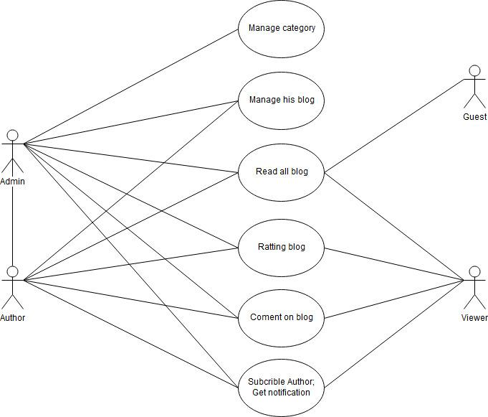

## The Admin

### Manage Category

The admin can manageable the categories: Edit, Add new, Delete.

This is an action which only admin have the permission to intervene

### Manage Account

Only the admin can do this action. They can Add new user, Edit or maybe delete it

## The Author

### Manage his own post

### Rating other post

## The Viewer

### Read, comment, rate all post on the website

## The Guess

i. Read blog as guess

Instead of register, The guess cannot comment or rate any blog of website.

They will be recommended (invited) to sign up. When the guess is registered, they can interact all the blog as the viewer

# Database

## DB Relationship Diagram

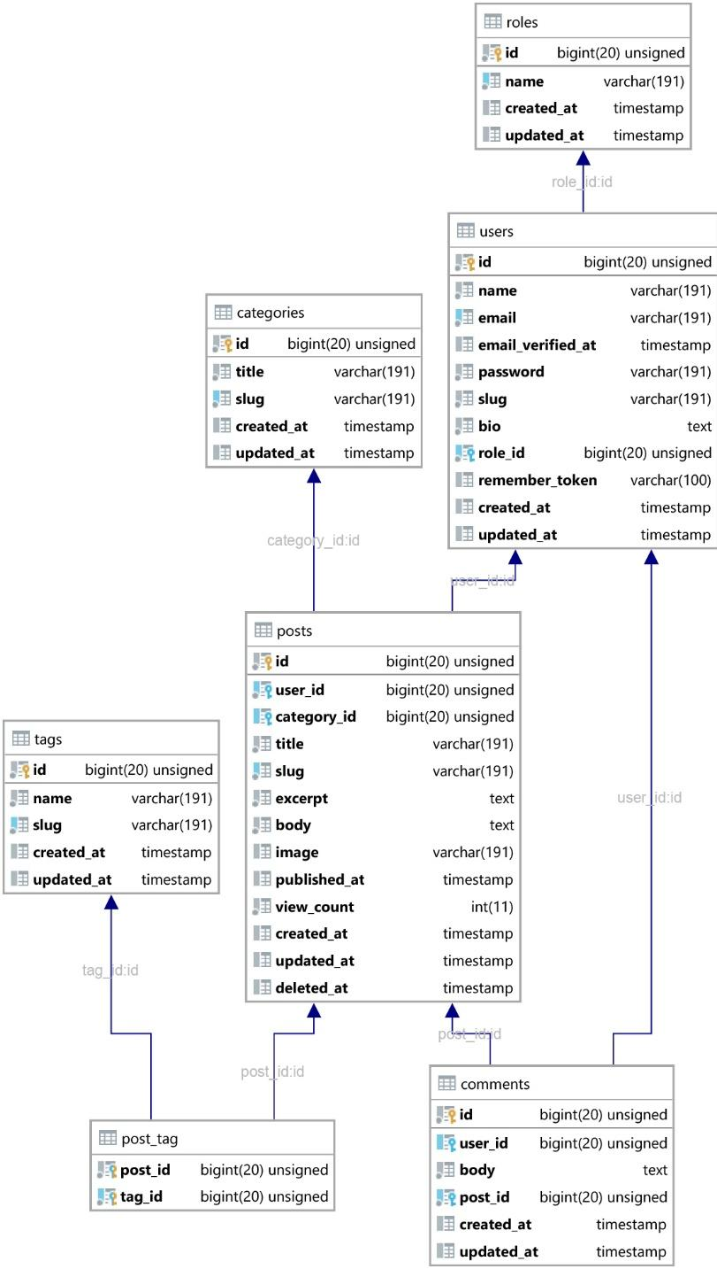

## Table: User

|  |  |  |  |  |
| --- | --- | --- | --- | --- |
| **Column Name** | **Data Type** | **Attributes** | **Null** | **Description** |
| **id** | bigint(20) | UNSIGNED (PK) | No | identify a account |
| **name** | varchar(191) |  | No | name of user who made this account |
| **email** | varchar(191) |  | No | store email of user in case of losing password |
| **email_verified_at** | timestamp |  | Yes | check the account has been activated or not |
| **password** | varchar(191) |  | No |  |
| **slug** | varchar(191) |  | No |  |
| **bio** | text |  | No | short biographical profile of user |
| **role_id** | bigint(20) | UNSIGNED (FK) | No | link to role table |
| **remember_token** | varchar(100) |  | Yes | set token help user want to auto login next time |

## Table: Post

|  |  |  |  |  |
| --- | --- | --- | --- | --- |
| **Name** | **Type** | **Attributes** | **Null** | **Comments** |
| **id** | bigint(20) | UNSIGNED (PK) | No | identify a post |
| **user_id** | bigint(20) | UNSIGNED (FK) | No | link to user table who wrote this post |
| **category_id** | bigint(20) | UNSIGNED (FK) | Yes | link to category table |
| **title** | varchar(191) |  | No | title of a post |
| **slug** | varchar(191) |  | No | make for SEO |
| **excerpt** | text |  | No | quick summary this post |
| **body** | text |  | No | all the content of post |
| **image** | varchar(191) |  | Yes | animating the post |
| **published_at** | timestamp |  | Yes | set the day to publish |
| **view_count** | int(11) |  | No | count the view |
| **deleted_at** | timestamp |  | Yes | store the day of abort post |

## Table: Category

|  |  |  |  |  |
| --- | --- | --- | --- | --- |
| **Name** | **Type** | **Attributes** | **Null** | **Comments** |
| **id** | bigint(20) | UNSIGNED (PK) | No | identify a category |
| **title** | varchar(191) |  | No | name of category |
| **slug** | varchar(191) |  | No | make for SEO |

## Table: Comment

|  |  |  |  |  |
| --- | --- | --- | --- | --- |
| **Name** | **Type** | **Attributes** | **Null** | **Comments** |
| **id** | bigint(20) | UNSIGNED (PK) | No | identify comment |
| **user_id** | bigint(20) | UNSIGNED (FK) | Yes | link to user table |
| **body** | text |  | No | content of comment |
| **post_id** | bigint(20) | UNSIGNED (FK) | No | link to post table |

## Table: Post_tag

Connect between Post table and Tag table

|  |  |  |  |  |
| --- | --- | --- | --- | --- |
| **Name** | **Type** | **Attributes** | **Null** | **Comments** |
| **post_id** | bigint(20) | UNSIGNED | No | link to post table |
| **tag_id** | bigint(20) | UNSIGNED | No | link to tag table |

## Table: Tags

|  |  |  |  |  |
| --- | --- | --- | --- | --- |
| **Name** | **Type** | **Attributes** | **Null** | **Comments** |
| **id** | bigint(20) | UNSIGNED (PK) | No | identify tag |
| **name** | varchar(191) |  | No | name of tag |
| **slug** | varchar(191) |  | No | good for SEO |

## Table: Roles

|  |  |  |  |  |
| --- | --- | --- | --- | --- |
| **Name** | **Type** | **Attributes** | **Null** | **Comments** |
| **id** | bigint(20) | UNSIGNED (PK) | No | identify role |
| **name** | varchar(191) |  | No | name of role |

# UI\UX

**USER SITE**

## Login Form

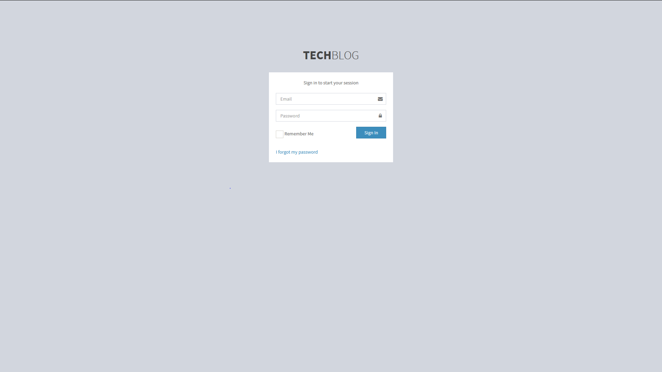

## Homepage

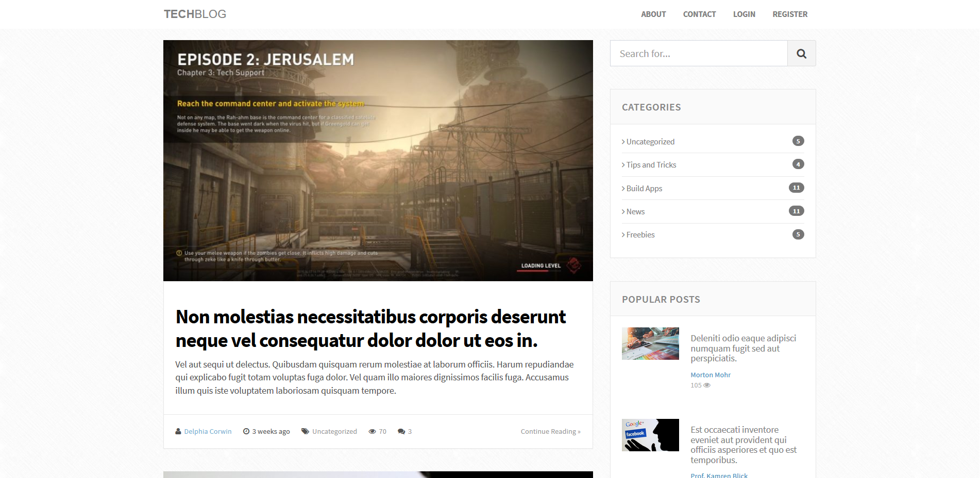

* 1. **Overview a post on homepage**

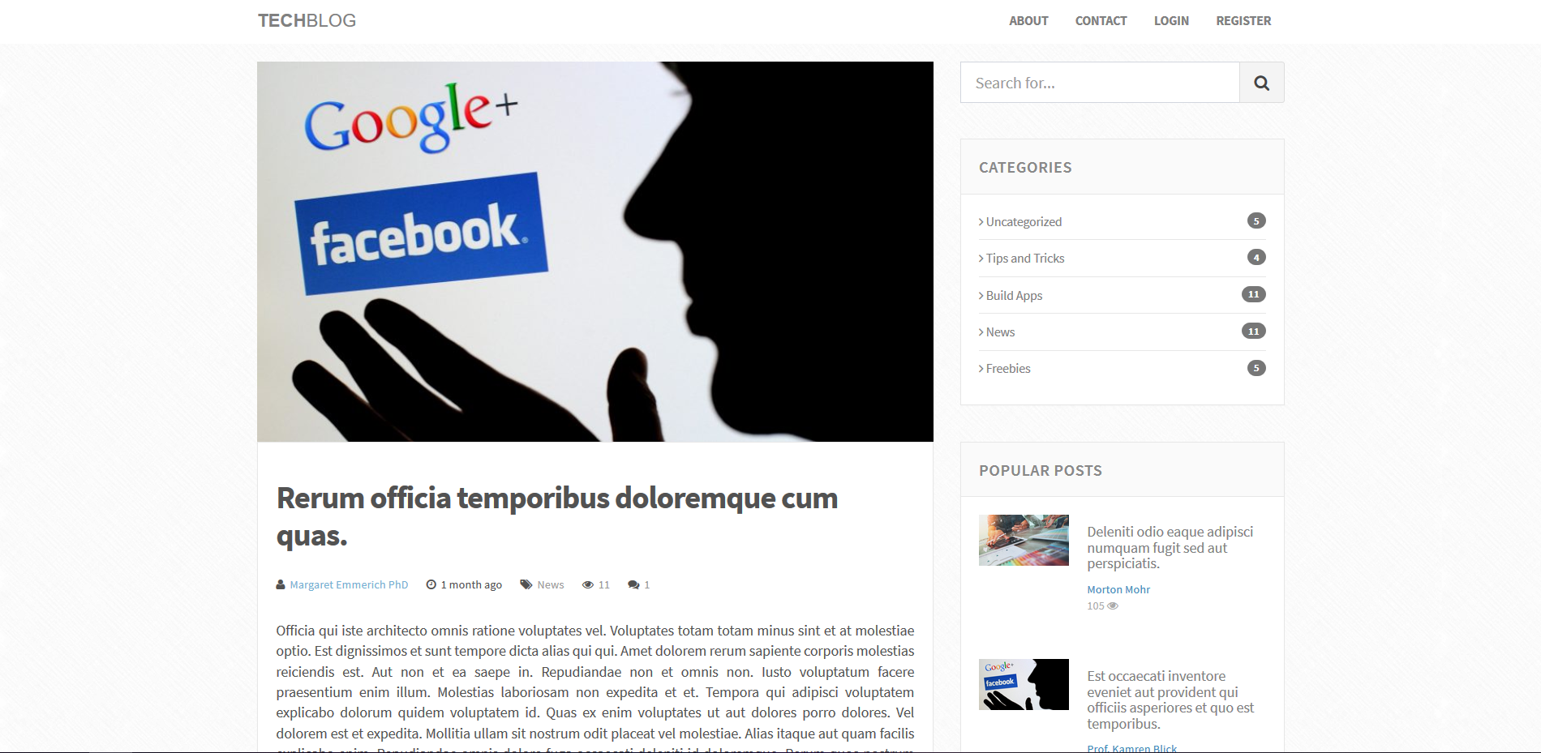

* 1. **Quick detail of a post**



## Full detail of a post

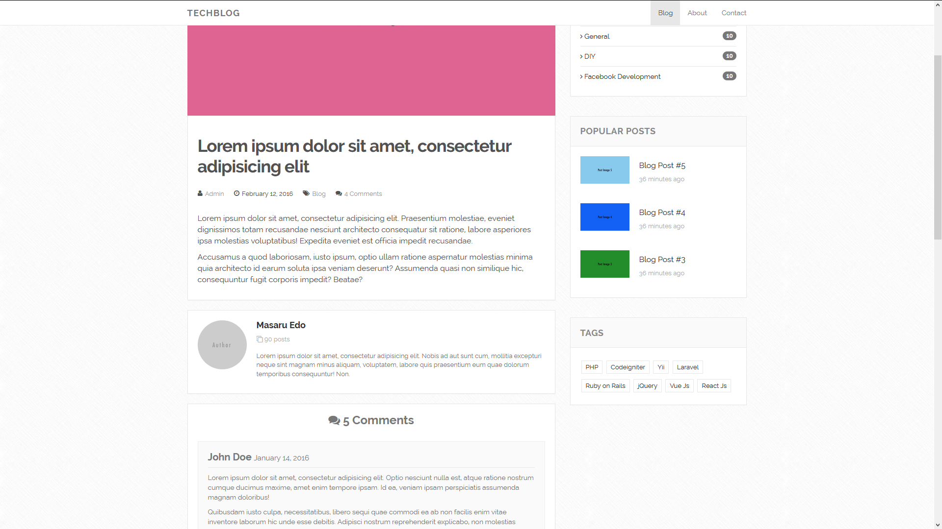

## Leave a comment

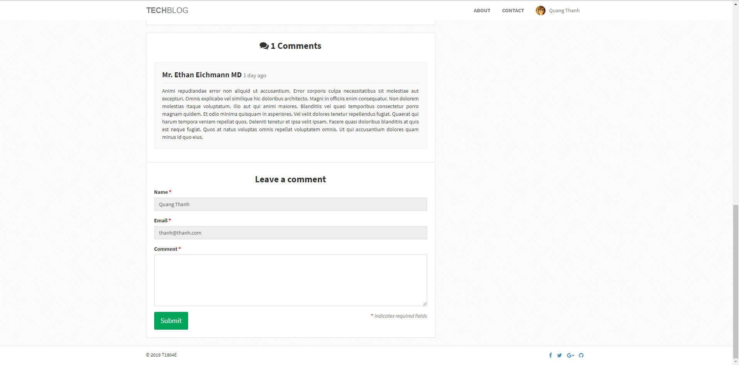

## Choose to read blog by category

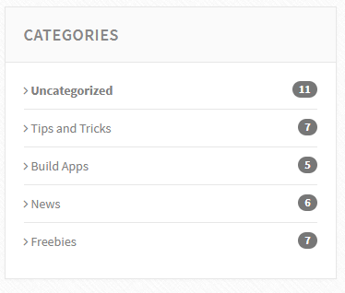

## Suggest popular post

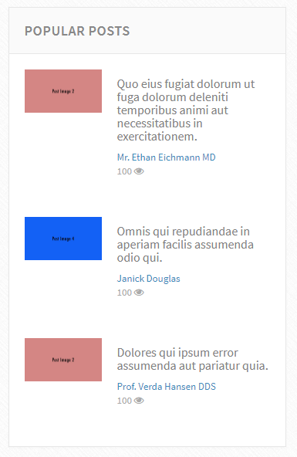

## Choose to read blog by tag

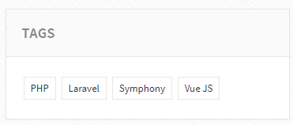

## About us

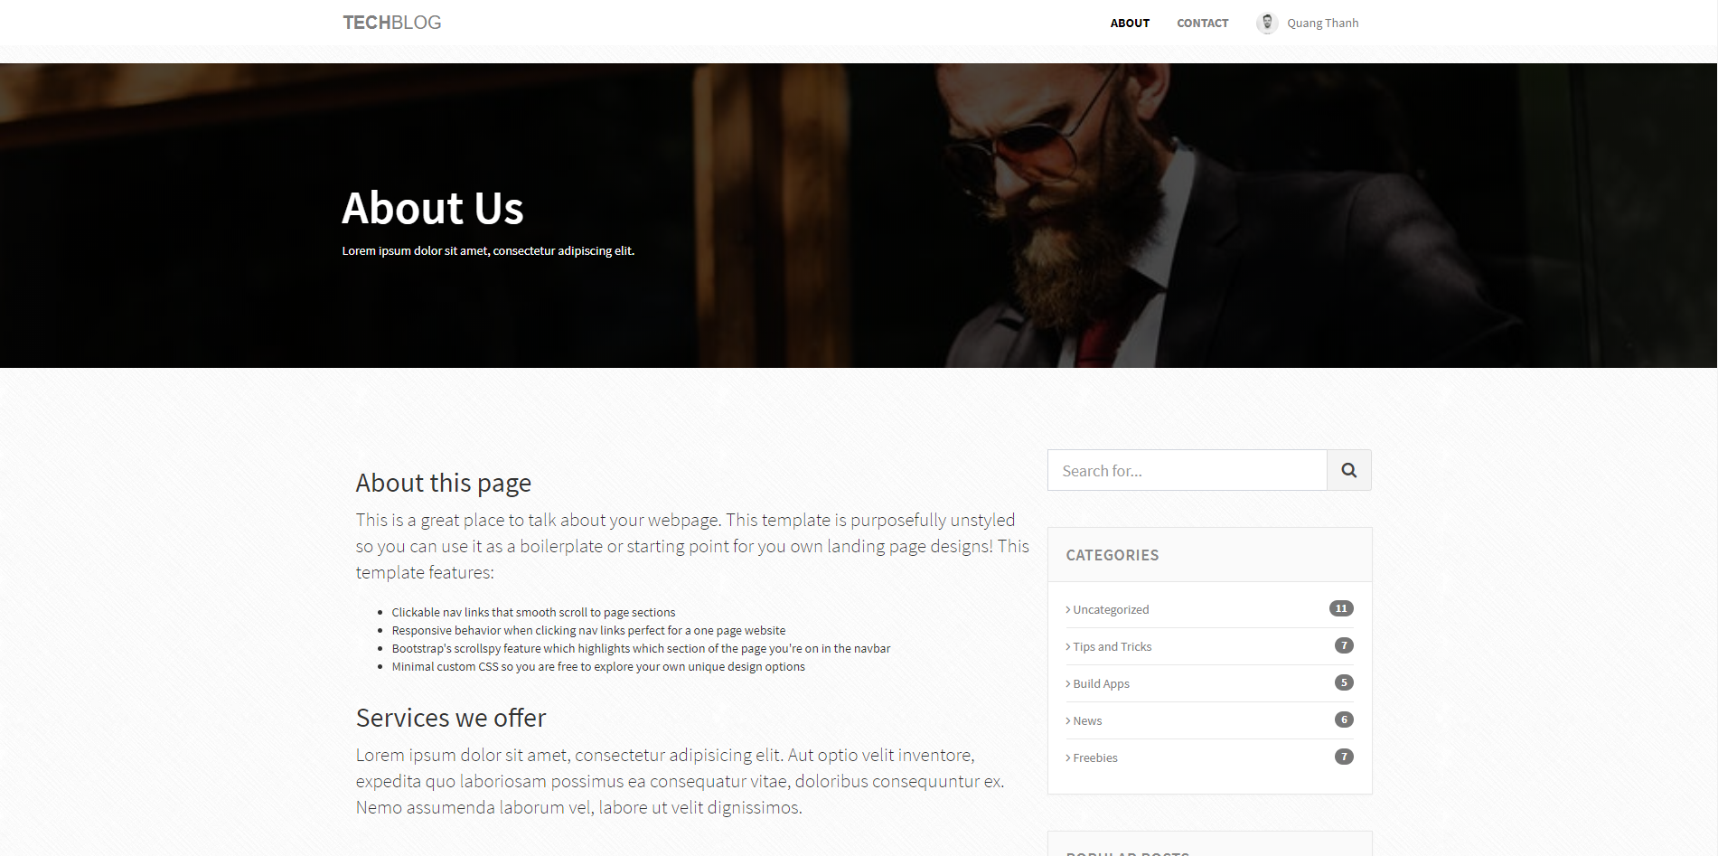

## Contact us

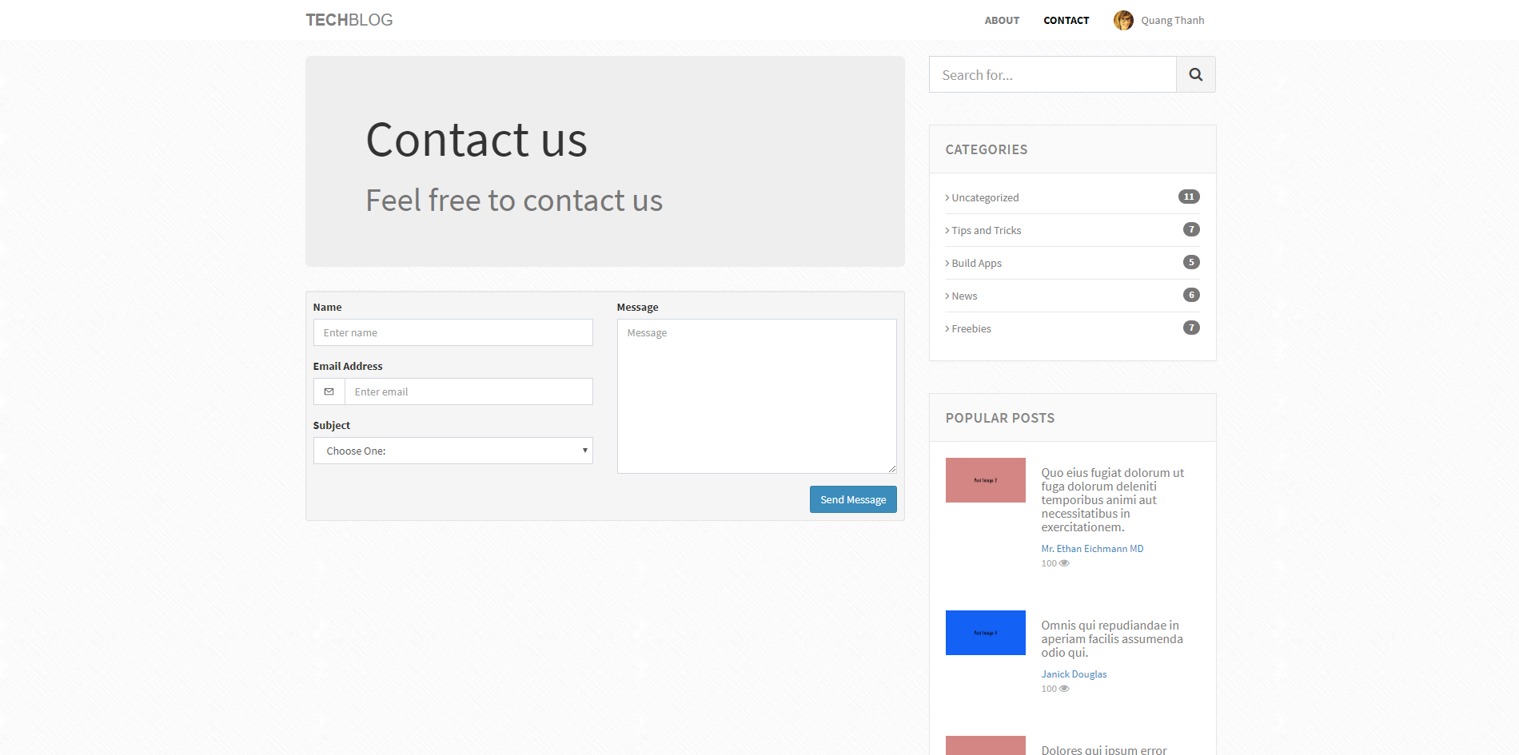

**ADMIN SITE**

## View all blog

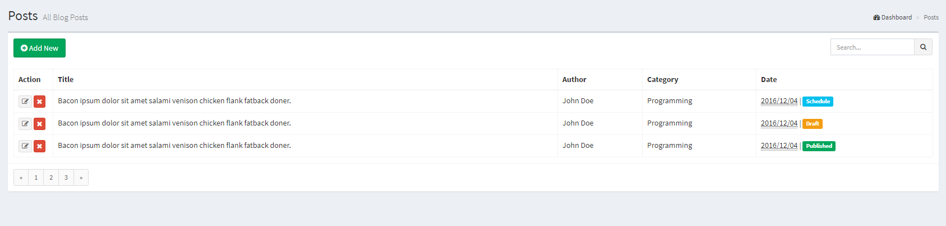

## Action can do with blog: edit or delete

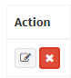

## Add new post

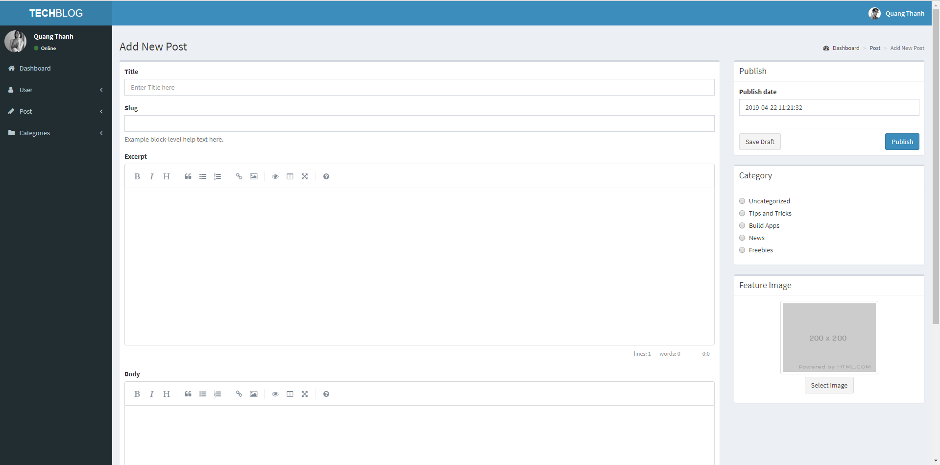

## Edit post

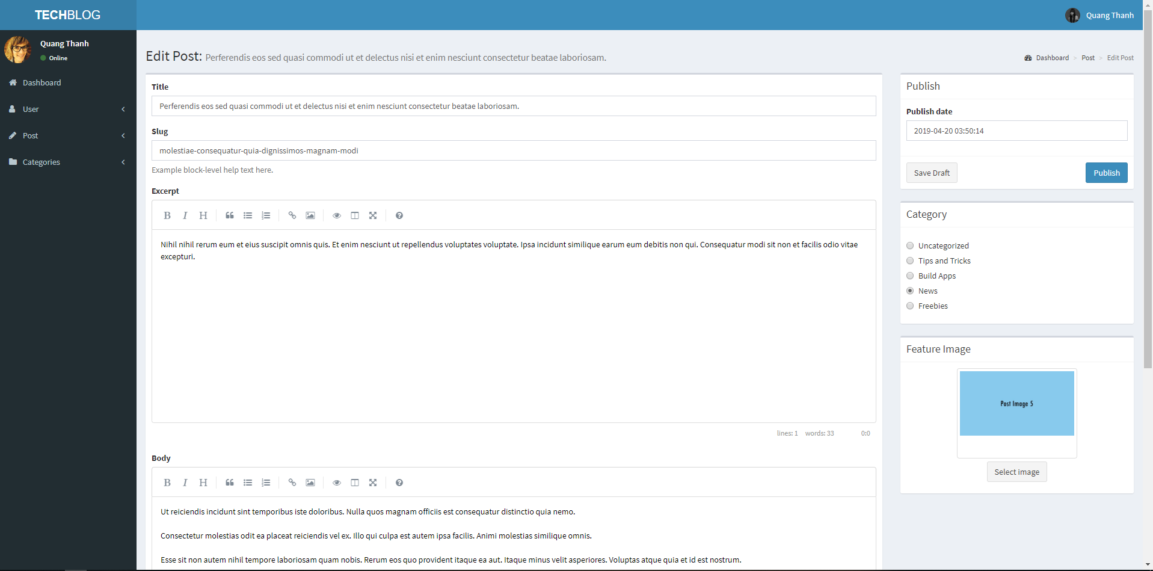

## View all user

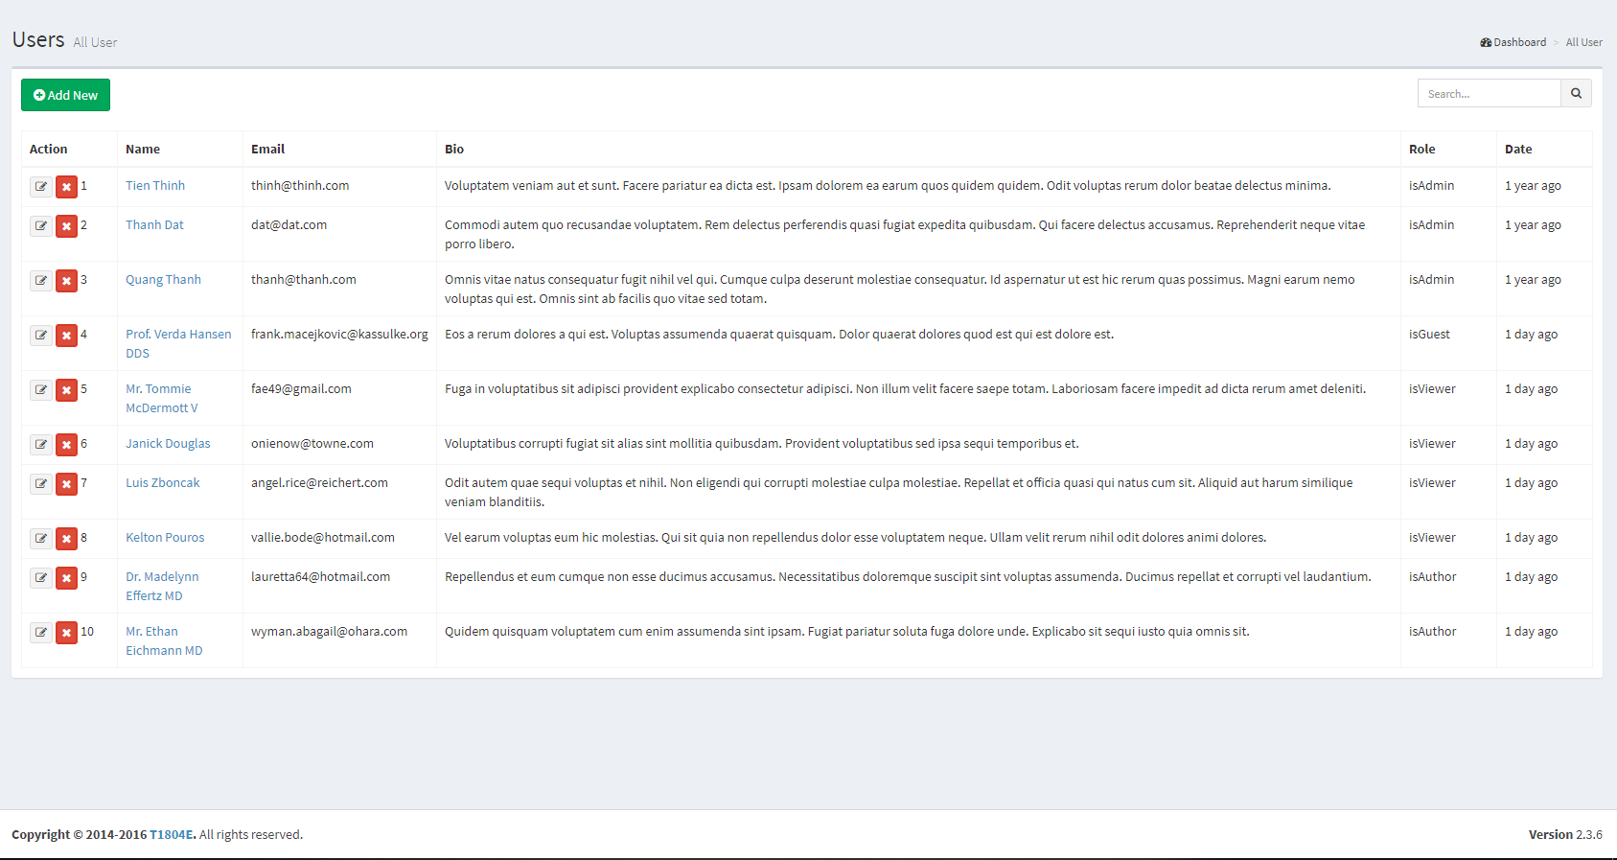

## Manage user action: Edit or Delete



## Add new user

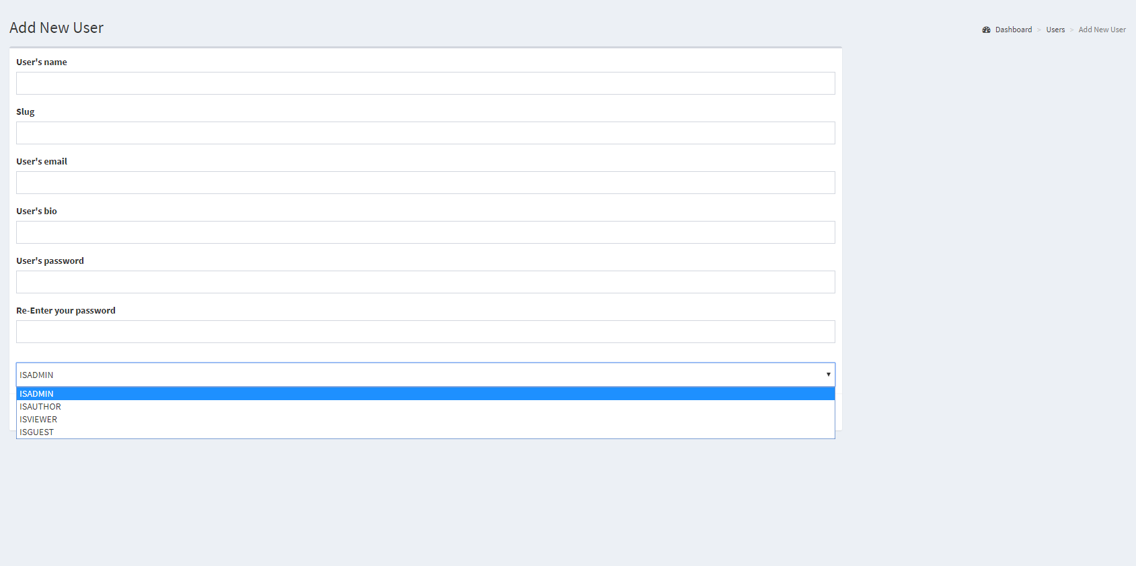

## Edit user

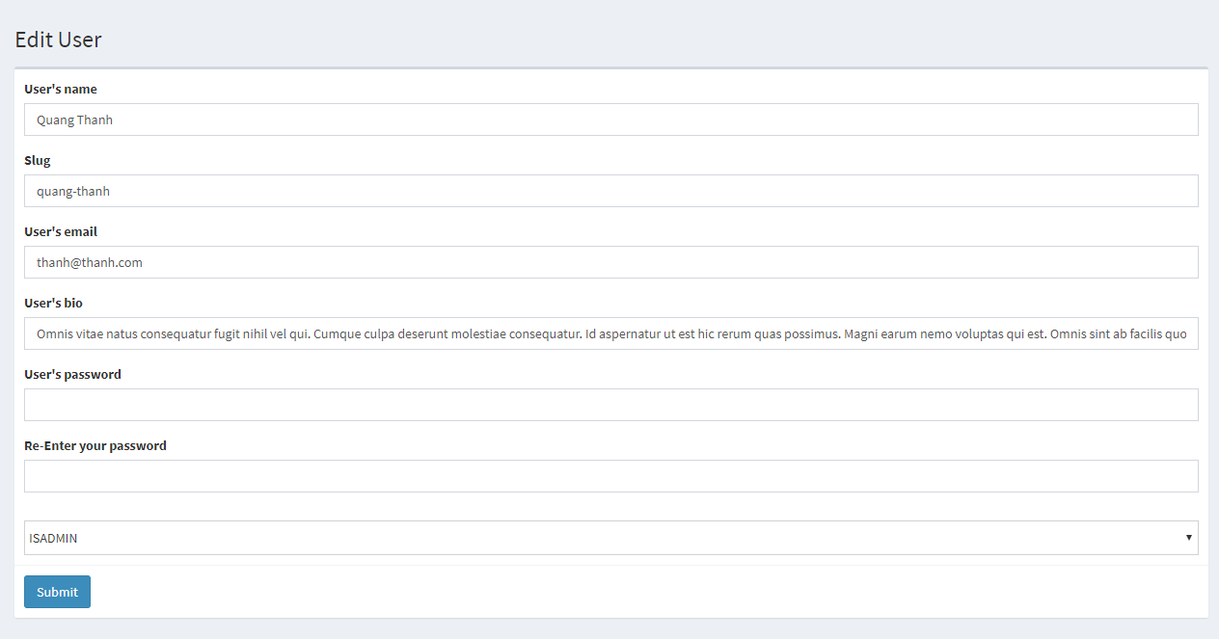

* 1. Category

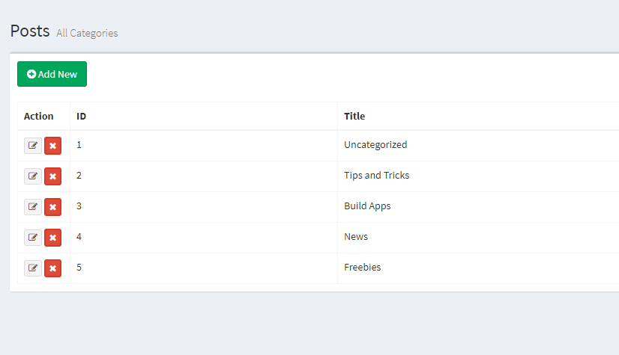

* 1. Add new category

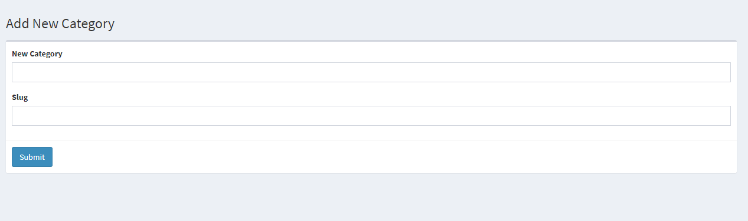

# Summary